**Mid-Semester Internship Report**

MapmyIndia, Bengaluru



by

Name - Devyash Parihar Id - 2016A7PS0066P



**Birla Institute of Technology and Science, Pilani**

(September’19)

**A REPORT**

on

**PART 1** - Intrinsic and Extrinsic Camera Calibration

**PART 2** - Road objects detection and segmentation

by

Devyash Parihar

2016A7PS0066P

B.E. (Hons.) Computer Science

***Prepared in partial fulfilment of the***

Practice School II Course

at

MapmyIndia, Bengaluru

a Practice School II Station of

**BIRLA INSTITUTE OF TECHNOLOGY AND SCIENCE, PILANI**

(September, 2019)

**BIRLA INSTITUTE OF TECHNOLOGY AND SCIENCE**

**PILANI (RAJASTHAN)**

**Practice School Division**

**Station:** MapmyIndia **Centre:** Bengaluru

**Duration:** July’19 - December’19 **Date of Start:** July 8, 2019

**Date of Submission:** September 16, 2019

**Title of the Project:**  Intrinsic and Extrinsic camera calibration, Road objects detection and segmentation

**ID No./Name(s)/:** 2016A7PS0066P, Devyash Parihar, B.E. (Hons.) Computer Science

**Discipline(s) of the**

**Student(s)**

**Name(s) and:** Muraleedhara Navada, Technical Manager, MapmyIndia Bengaluru

**Designation(s)**

**of the expert(s)**

**Name(s) of the:** Seetha Parameswaran

**PS Faculty**

**Key Words:**Machine Learning, Deep Learning, Computer Vision, Artificial Intelligence, MaskRCNN, VPGNet, OpenCV, Python

**Project Areas:** Computer Vision, AI

**Abstract:**

High Definition Maps or HD Maps for short are particularly built for self-driving purposes. These maps specifically have extremely high precision at centimeter-level. 3D computer vision and Deep Neural Network are the technologies driving the development of high- definition live maps for self-driving cars. The very basic problems for this are segmentation and detection of road object and lanes, requiring large and diverse datasets.

Signature(s) of Student(s) Signature of PS Faculty

Date

**BIRLA INSTITUTE OF TECHNOLOGY AND SCIENCE**

**PILANI (RAJASTHAN)**

**PRACTICE SCHOOL DIVISION**

# **Response Option Sheet**

Station: **MapmyIndia** Center: **Bengaluru**

ID No. & Name(s): **2016A7PS0066P** & **Devyash Parihar**

Title of the Project: **Intrinsic and Extrinsic camera calibration, Road objects detection and segmentation.**

Usefulness of the project to the on-campus courses of study in various disciplines. Project should be scrutinized keeping in view the following response options. Write Course No. and Course Name against the option under which the project comes.

Refer Bulletin for Course No. and Course Name.

|  |  |  |
| --- | --- | --- |
| Code No. | Response Option | Course No.(s) & Name |
| 1. | A new course can be designed out of this project. |  |
| 2. | The project can help modification of the course content of some of the existing Courses |  |
| 3. | The project can be used directly in some of the existing Compulsory Discipline Courses (CDC)/ Discipline Courses Other than Compulsory (DCOC)/ Emerging Area (EA), etc. Courses |  |
| 4. | The project can be used in preparatory courses like Analysis and Application Oriented Courses (AAOC)/ Engineering Science (ES)/ Technical Art (TA) and Core Courses. |  |
| 5. | This project cannot come under any of the above mentioned options as it relates to the professional work of the host organization. |  |

_______________ ________________

Signature of Student Signature of Faculty

Date: September 16, 2019 Date: September 16, 2019

**Acknowledgments**

* Mr. Muraleedhara Navada, Technical Manager, MapmyIndia Bengaluru, for his constant guidance, regular feedbacks, reviews and suggestions.
* Ms. Seetha Parameswaran, Practice School Instructor, BITS Pilani, for her guidance during initial days of the internship and being helpful throughout the period.
* The software and AI team, for always being helpful and sharing their experiences regarding the work related to our project.
* Poetry Corner, the weekly presentation platform for keeping us updated on various latest technologies and the work done in the organization. We have been learning here a lot and hope to continue to, for the remaining of the period of our internship.
* All the employees of the organization for providing a wonderful environment to work in.

TABLE OF CONTENTS

|  |  |  |
| --- | --- | --- |
| S/no | Contents | Page no |
| 1 | Cover Page | 0 |
| 2 | Title Page | 1 |
| 3 | Abstract Sheet | 2 |
| 4 | Response Option Sheet | 3 |
| 5 | Acknowledgment | 4 |
| 6 | Table of Contents | 5 |
| 6 | 1.1 Intrinsic and Extrinsic Camera Parameters | 8-9 |
| 7 | 1.2Intrinsic Calibration, using Checkerboard | 10-14 |
| 8 | 1.3 Extrinsic Calibration, using ArUco Markers | 15-16 |
| 8 | 2.1 Mask R-CNN for instance segmentation | 17-25 |
| 9 | 2.2 Vanishing Point Guided Network for Lane and Road Marking Detection and Recognition (VPGNet) | 25-29 |
| 10 | Conclusion | 29-30 |
| 11 | References | 30 |

**Introduction**

As is our work, this report has been divided in 2 parts. The first part involves the calculation of intrinsic and extrinsic parameters of cameras while the second revolves around Road objects detection and segmentation using Mask R-CNN & VPGNet architectures.

**PART I**

In computer vision, geometry describes the structure and shape of the world. It concerns measures such as depth, volume, shape, pose, disparity, motion or optical flow. Simple geometry can be used to study the formation of images by projection through a camera, simple mathematical rules to study the relation between a point in the world and the same point as seen in an image. Calculating various parameters like focal length of the camera, projection information and pose information of the camera can enable us to find depth of various objects in images, in the real world, and thus potentially, recreating the whole 3D world from images, again, by using simple geometry!

**PART II**

Both object detection and semantic segmentation of camera images are important tasks for automated vehicles. Object detection is necessary so that the planning and behavior modules can reason about other road users. Semantic segmentation provides for example free space information and information about static and dynamic parts of the environment. There has been a lot of research to solve both tasks using Convolutional Neural Networks. Mask R-CNN and VPGNet are two of many such Convolution Neural Networks based models.

**PART 1 - Intrinsic and Extrinsic Camera Calibration**

***1.1 Intrinsic and Extrinsic Camera Parameters***

### *Basic Pinhole camera Model*

The pinhole camera model is used to understand the formation of images. In this model, a scene view is formed by projecting 3D points into the image plane using a perspective transformation.

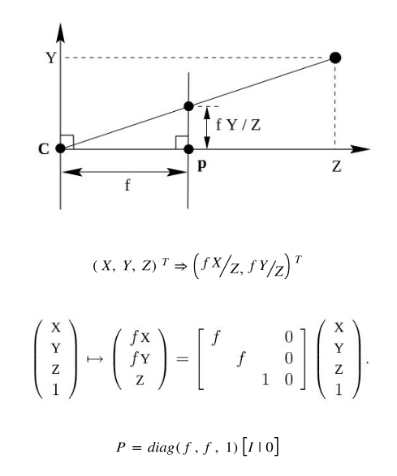

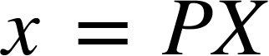 represents the general relation between 2D image coordinates of a point and its corresponding 3D world coordinates where,

*x* is the 2D image coordinates vector

*X* is 3D world coordinates vector

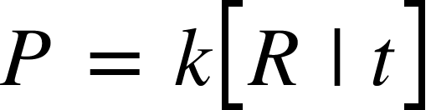

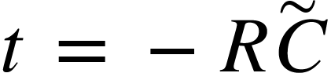, is translation vector

*R* is the rotation matrix

is camera coordinates vector

and *k* is the intrinsic camera matrix

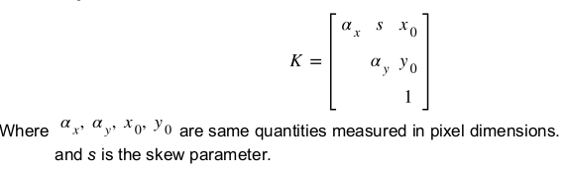

where, 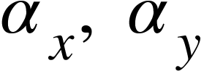 are focal lengths of camera on each axis

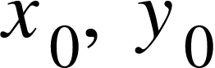 are principal point coordinates

and *s* is the skew parameter

All the above parameters involved with *k* compose the **intrinsic parameters**.

Apart from these, distortion coefficients can also be calculated to undistort the image if required.

The calculation of *R*, *t* is called the **extrinsic calibration.**

### *Epipolar Geometry and Fundamental Geometry*

The epipolar geometry between two views is essentially the geometry of the intersection of the image planes with the pencil of planes having the baseline as axis (the baseline is the line joining the camera centres).

### image*Fundamental Matrix*

The fundamental matrix(F) is the algebraic representation of epipolar geometry. For an image point x and its corresponding point in the other image x',



***1.2 Intrinsic Calibration, using Checkerboard***

A simple flowchart to depict the whole process of intrinsic calibration of camera using checkerboard images -

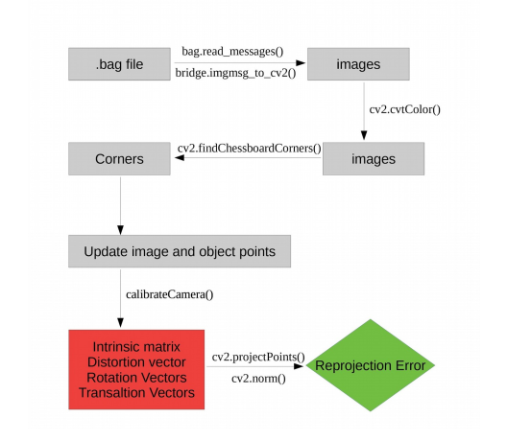

### *BAG Files (Preprocessing)*

A bag is a file format in ROS for storing ROS message data. Bags -- so named because of their .bag extension -- have an important role in ROS, and a variety of tools have been written to allow you to store, process, analyze, and visualize them. Bags are typically created by a tool like rosbag, which subscribe to one or more ROS topics, and store the serialized message data in a file as it is received. These bag files can also be played back in ROS to the same topics they were recorded from or even remapped to new topics.

We can use the following command to get the details of a bag file: rosbag info foo.bag The output might look something like this:

### *Image Extraction*

The images contained in the bag file can be extracted using the below given code snippet: Command to run the below code: python program_name.py bag_file.bag path_name image_topic bag_file: name of the bag file path_name: path of the directory where images will be stored. image_topic: topic of the image e.g. /frontNear/left/image_raw/

### 

Run the above code and store the corresponding images in the left and right directories(based on the topics of the messages). Note that the directory for storing the left and right images needs to be created before running the code.

### Important Functions Used

* ***compare_ssim***: Compute the mean structural similarity index between two images.
* ***cv2.findChessboardCorners***: Finds positions of the internal corners of the chessboard. Returns a boolean value depending on if the given shape of corners are found, also returns location of the corners if true.
* ***cv2.cornerSubPix***: The function iterates to find the sub-pixel accurate location of corners or radial saddle points.
* ***cv2.drawChessboardCorners***: Renders the detected chessboard corners.
* ***cv2.calibrateCamera***: Finds the camera intrinsic and extrinsic parameters from several views of a calibration pattern. Returns the rotation and translation matrix corresponding to each pattern. Also returns the camera intrinsic and distortion vector corresponding to lowest reprojection error.
* ***cv2.projectPoints***: Projects 3D points to an image. Used for calculating the reprojection error.
* ***cv2.norm***: Calculates the absolute or relative difference norm between the given image matrices.

### *Results*

The algorithm takes 40 patterns from the given sample to calibrate the given camera. To cover all the possible orientations of the checkerboard, the selected sample images must be different in orientations. Three techniques have been used to select such samples- ***Simply selecting first 40 images***: Very low reprojection error suggests a possibility of images with similar orientations of the board been selected for calibration. Therefore, a technique to select “good” images from the sample is required.

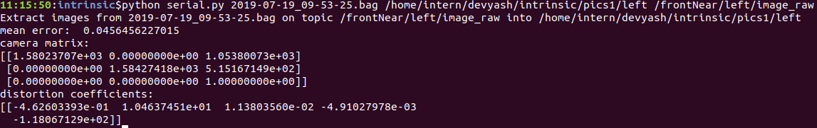

***Skipping a few images after each image***: Another approach we came up with is to skip about 20 to 25 images after selecting one so as to keep the variation amongst the selected images. The results obtained on including every 30th image are: 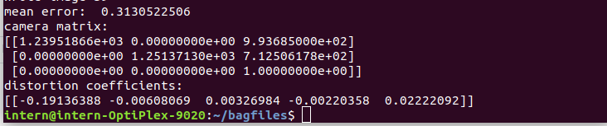

**a. Results with threshold SSIM = 0.65:**

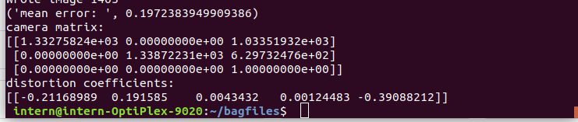

**b. Results with threshold SSIM = 0.62:**

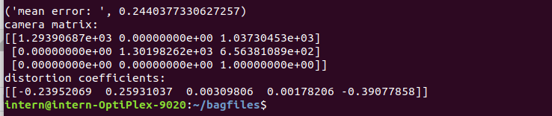

**A plot of threshold value of ssim of selected images(X) against the reprojection error(Y) -**

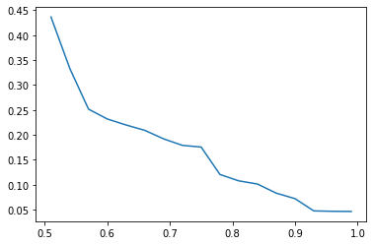

***1.3 Extrinsic Calibration, using ArUco Markers***

A simple flowchart to depict the process of extrinsic calibration of stereo cameras -

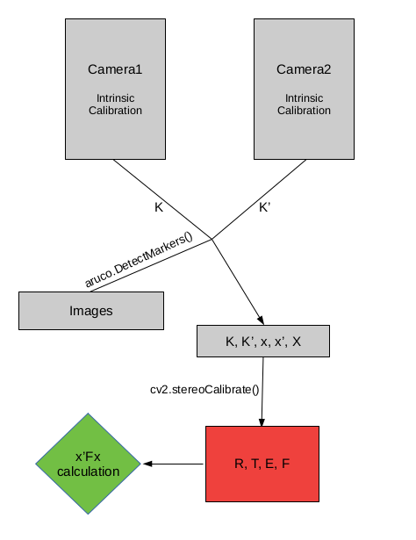

### *Images*

The images used for the extrinsic calibration of the cameras are images of an ArUco marker on a cardboard, as shown below,

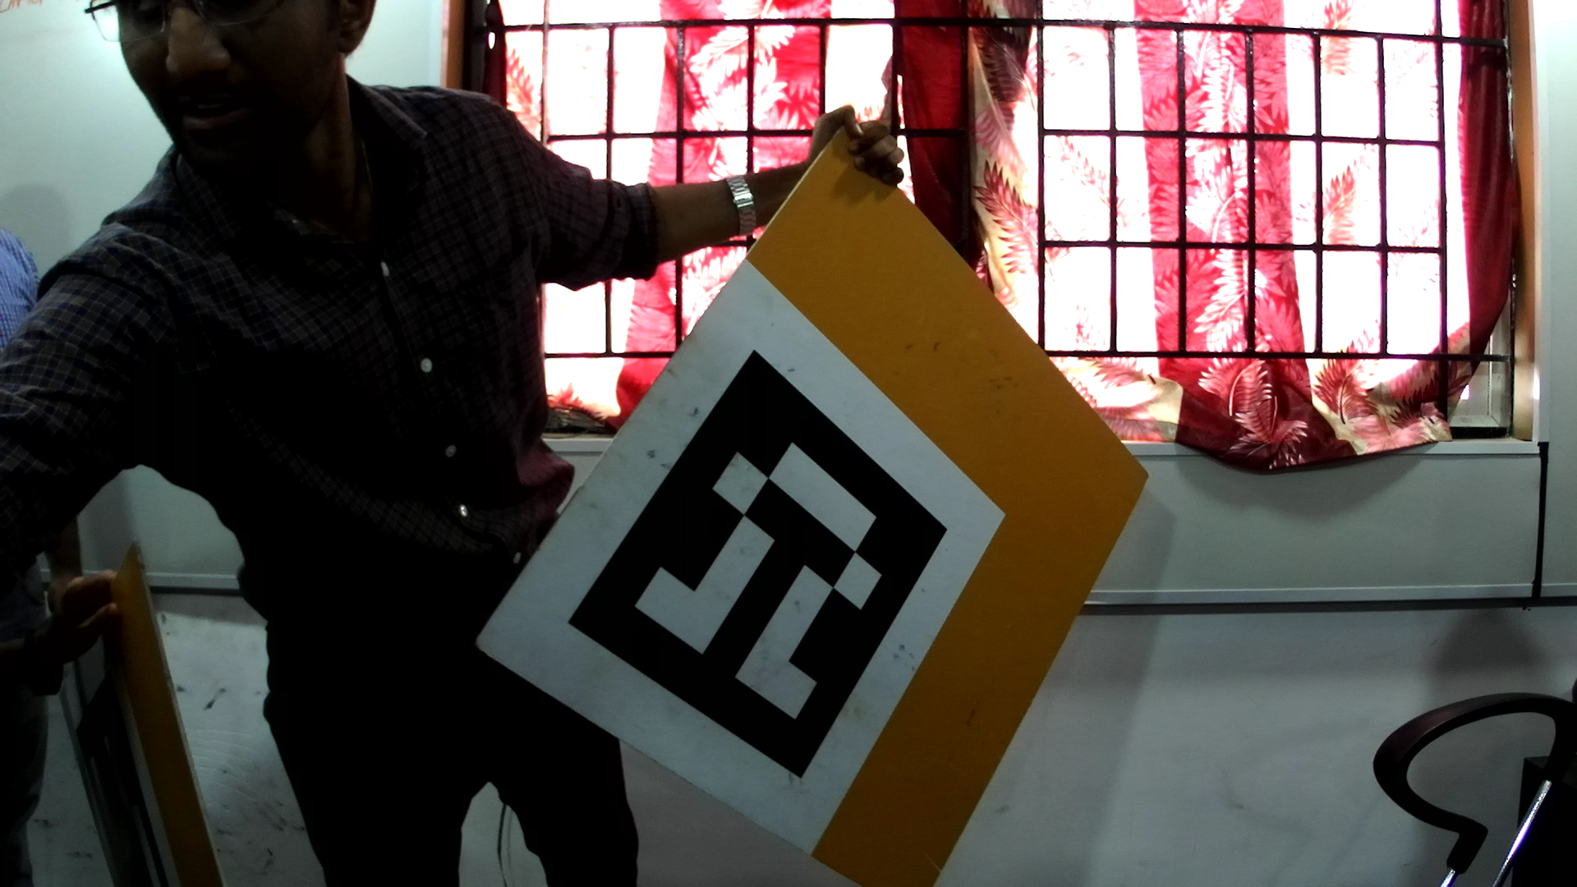

### *Important Functions*

* ***aruco.DetectMarkers()***: Function from the aruco library of OpenCV, detects the corners of the aruco marker and returns the id of the aruco marker along with image coordinates of the corners of the marker.
* ***cv2.stereoCalibrate()***: Given the camera matrices, object points and the corresponding image points in images from both of the stereo cameras, it calculates the R, T, E, F i.e. Rotation Vector, Translation Vector, Essential Matrix and the Fundamental Matrix respectively. R and T define the extrinsic calibration parameters between the two cameras.

### *Verification*

The results can be verified by calculating the value of-

*x’ F x = 0*

which is supposed to be equal to zero according to the standard fundamental matrix equation. Closer the value to 0, accurate are the results. x' and x in the above formula are the corresponding image coordinates in second and first image respectively.

**PART 2 - AI**

***2.1 Mask R-CNN for instance segmentation***

The vision community has rapidly improved object detection and semantic segmentation results over a short period of time. In large part, these advances have been driven by powerful baseline systems, such as the Fast/Faster RCNN and Fully Convolutional Network (FCN) frameworks for object detection and semantic segmentation, respectively. These methods are conceptually intuitive and offer flexibility and robustness, together with fast training and inference time.

Instance segmentation is challenging because it requires the correct detection of all objects in an image while also precisely segmenting each instance. It therefore combines elements from the classical computer vision tasks of object detection, where the goal is to classify individual objects and localize each using a bounding box, and semantic segmentation, where the goal is to classify each pixel into a fixed set of categories without differentiating object instances.

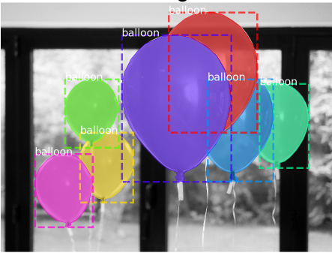

**Semantic segmentation**

Mask R-CNN, extends Faster R-CNN by adding a branch for predicting segmentation masks on each Region of Interest (RoI), in parallel with the existing branch for classification and bounding box regression. The mask branch is a small FCN applied to each RoI, predicting a segmentation mask in a pixel-to-pixel manner. Mask R-CNN is simple to implement and train given the Faster R-CNN framework, which facilitates a wide range of flexible architecture designs. Additionally, the mask branch only adds a small computational overhead, enabling a fast system and rapid experimentation.

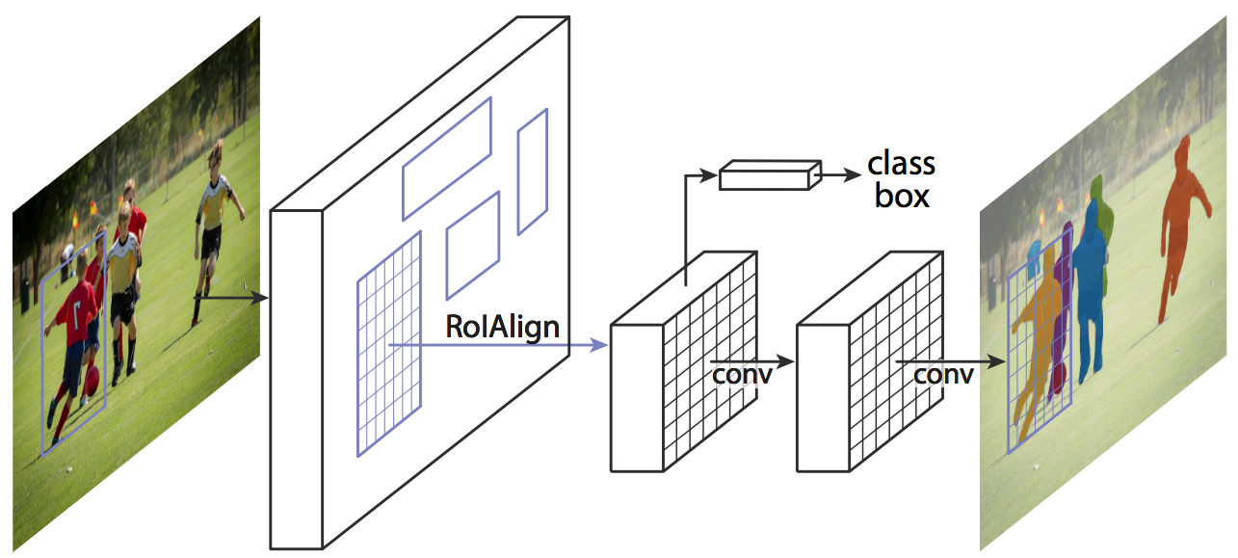

It consists of a **backbone network** which is a standard CNN such as ResNet50 or ResNet101. The early layer of network detect low-level features, and later layers detect higher-level features. The image is converted from 1024x1024px x 3 (RGB) to a feature map of shape 32x32x2048. The **Feature Pyramid Network (FPN)** was an extension of the backbone network which can better represent objects at multiple scales. It consists of two pyramids where the second pyramid receives the high-level features from the first pyramid and passes them to the lower layers. This allows every level to have access to both lower and higher level features.

It also uses the **Region Proposal Network (RPN)** which scans all FPN top to bottom and proposes regions which may contain objects. It uses anchors which are a set of boxes with predefined locations and scales itself according to the input images. Individual anchors are assigned to the ground-truth classes and bounding boxes. RPN generates two outputs for each anchor — anchor class and bounding box specifications. The anchor class is either foreground class or a background class.

Another module that is different in Mask R-CNN is the **ROI Pooling**. The authors of Mask R-CNN concluded that the regions of the feature map selected by RoIPool were slightly misaligned from the regions of the original image. Since image segmentation requires specificity at the pixel level of the image, this leads to inaccuracies. This problem was solved by using **RoIAlign** in which the feature map is sampled at different points and then a bilinear interpolation is applied to get a precise idea of what would be at pixel 2.93 (which was earlier considered as pixel 2 by the RoIPool).

Then a convolutional network is used which takes the regions selected by the ROI classifier and generates masks for them. The generated masks are of low resolution- 28x28 pixels. During training, the masks are scaled down to 28x28 to compute the loss, and during inferencing, the predicted masks are scaled up to the size of the ROI bounding box. This gives us the final masks for every object.

***2.1.1 Step by step detection:***

1. *Anchor sorting and filtering* - Visualizes every step of the first stage Region Proposal Network and displays positive and negative anchors along with anchor box refinement.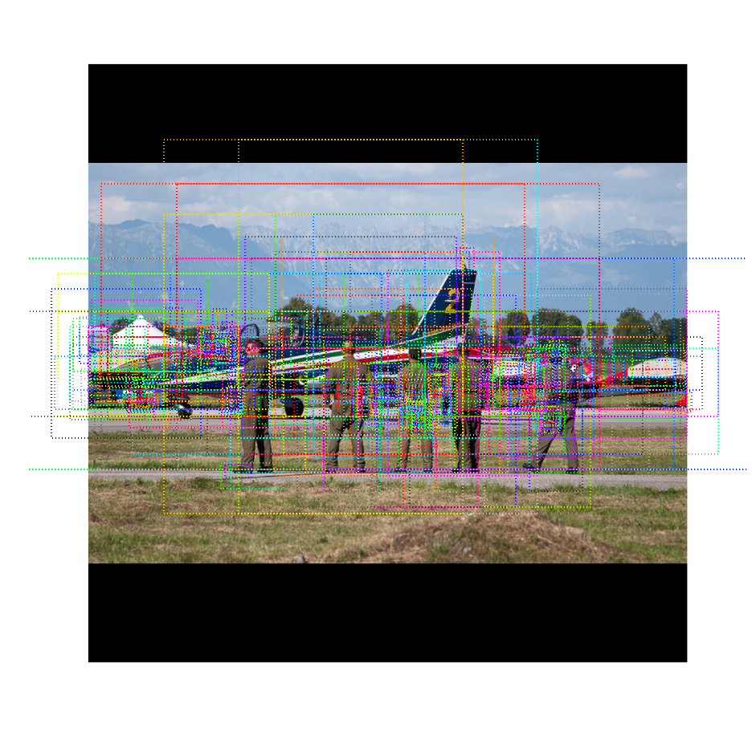
2. *Bounding Box Refinement* - This is an example of final detection boxes (dotted lines) and the refinement applied to them (solid lines) in the second stage.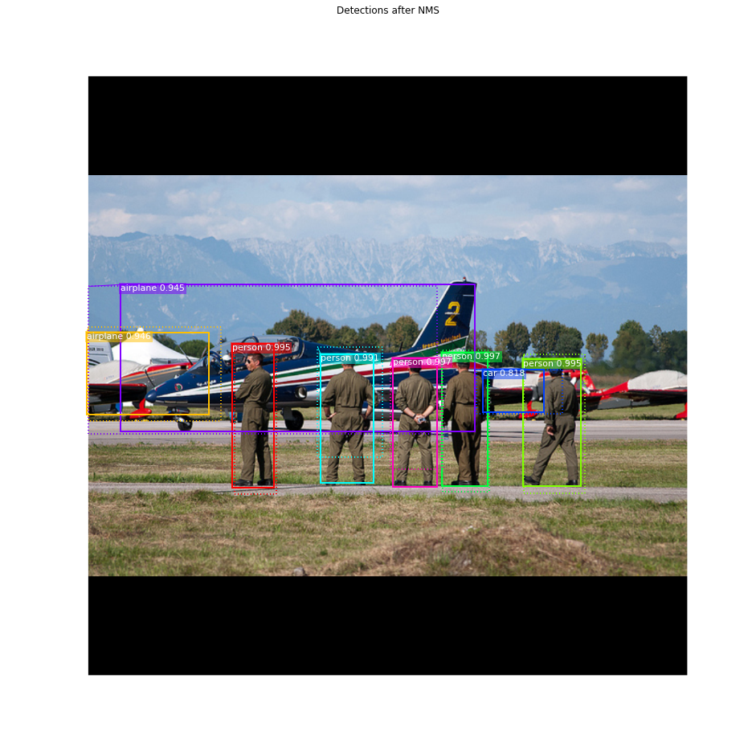
3. *Mask Generation* - These then get scaled and placed on the image in the right location.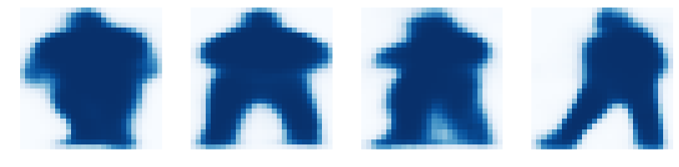
4. *Final result* - Composing the different pieces into a final result.

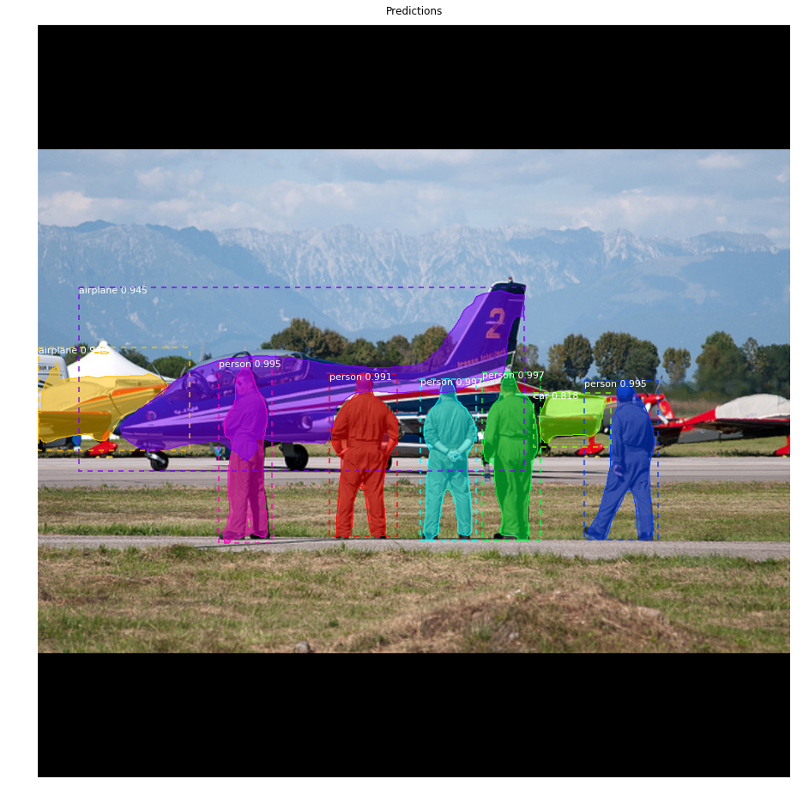

***2.1.2 About MS COCO (dataset used for training) :***

COCO is a large-scale object detection, segmentation, and captioning dataset. COCO has several features:

* Object segmentation
* Recognition in context
* Superpixel stuff segmentation
* 330K images (>200K labeled)
* 1.5 million object instances
* 80 object categories
* 91 stuff categories
* 5 captions per image
* 250,000 people with keypoints

***2.2 Vanishing Point Guided Network for Lane and Road Marking Detection and Recognition (VPGNet)***

VPGNet is a unified end-to-end trainable multi-task network that jointly handles lane and road marking detection and recognition that is guided by a vanishing point under adverse weather conditions.

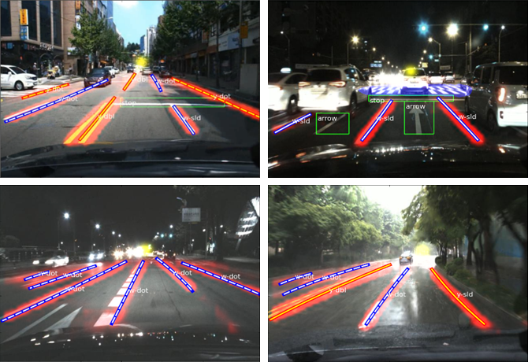

A vanishing point is a point where parallel lines in a three-dimensional space converge to a two-dimensional plane by a graphical perspective. In most cases of driving, lane and road markings converge to a single point regardless of whether the roads are curved or straight.

We propose a data layer to induce grid-level annotation that enables training of both lane and road markings simultaneously. Originally, the box regression task aims to fit a single box to a particular object. This works well for objects with a blob shape (traffic signs or vehicles), but lane and road markings cannot be represented by a single box. Therefore, an alternative regression is proposed that utilizes a grid-level mask. Points on the grid are regressed to the closest grid cell and combined by a multilabel classification task to represent an object. This enables us to integrate two independent targets, lane and road markings, which have different characteristics and shapes. For the post-processing, lane classes only use the output of the multi-label task, and road marking classes utilize both grid box regression and multi-label task. Additionally, we add a vanishing point detection task to infer a global geometric context during training of patterns of lane and road markings.

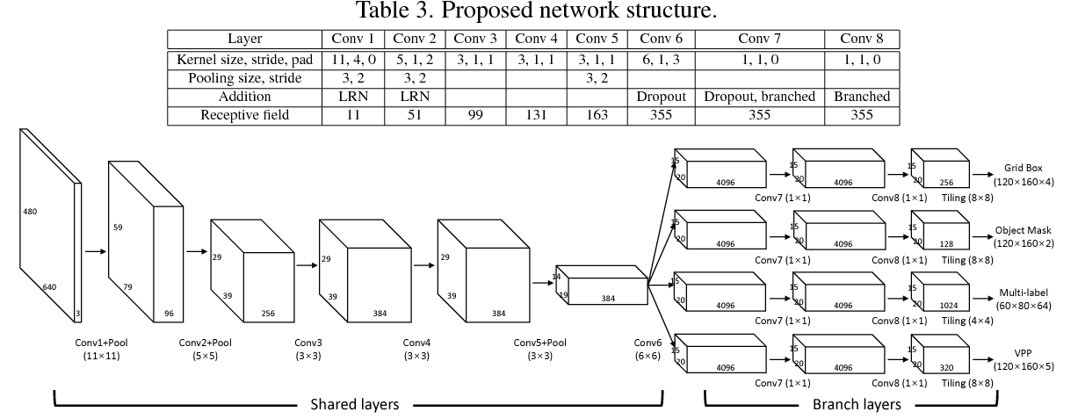

***2.2.1 About Caltech Lanes Dataset(dataset used for training) :***

Caltech Lanes dataset includes four clips taken around streets in Pasadena, CA at different times of day. The archive below includes 1225 individual frames as taken from a camera mounted on Alice in addition to the labeled lanes. The dataset is divided into four individual clips: ***cordova1*** with 250 frames, ***cordova2*** with 406 frames, ***washington1*** with 337 frames, and ***washington2*** with 232 frames.

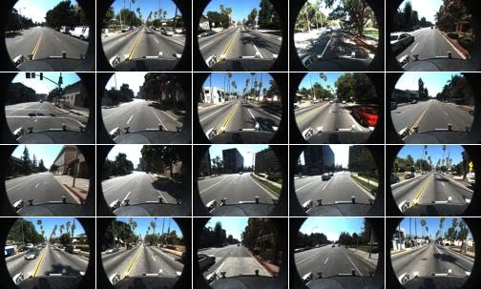

***2.2.2 Annotation :***

Corner points of lane and road markings are manually annotated. Corner points are connected to form a polygon which results in a pixel-level mask annotation for each object. In a similar manner, each pixel contains a class label.

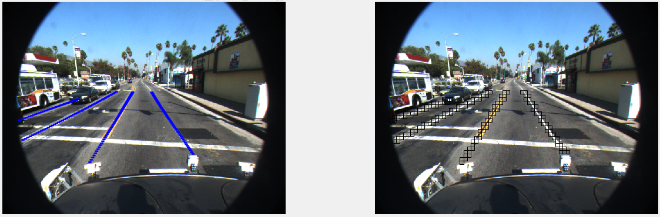

Sample annotation

***2.2.3 Progress till now :***

I trained the model on Caltech Lanes Dataset with the following configurations-

* test_iter : 2
* test_interval : 10
* base_lr : 0.005
* lr_policy : step
* gamma : 0.1
* max_iter : 1000
* momentum : 0.9
* solver_mode : CPU

The above parameters are with correspondence to the caffe framework’s ***solver.prototxt*** file.

As seen in the graphs below, the loss functions for the three branches of the network are converging in the nature.





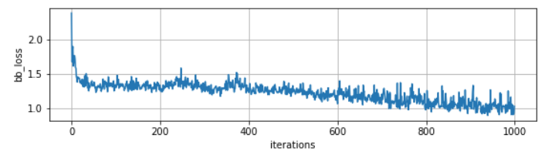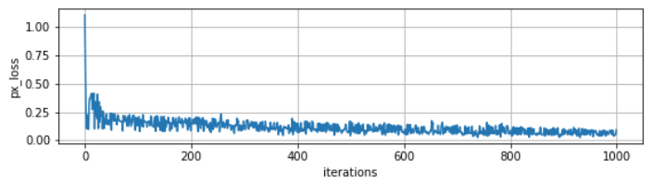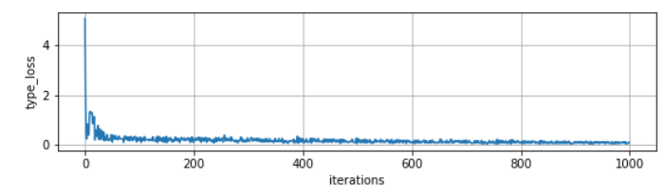

*Loss vs number of iterations for the three branches of the network*

**Conclusion**

Autonomous driving is a large system that consists of various sensors and control modules. The first key step for robust autonomous driving is to recognize and understand the environment around a subject. However, simple recognition of obstacles and understanding of geometry around a vehicle is insufficient. There are traffic regulations dictated by traffic symbols such as lane and road markings that should be complied with. Moreover, for an algorithm to be applicable to autonomous driving, it should be robust under diverse environments and perform in real-time.

There has been a lot of research going on this specific field lately. Private companies working in auto tech are attracting record levels of deals and funding, with autonomous driving startups leading the charge.

**References**

[1] S. Ren, K. He, R. Girshick, and J. Sun. Faster r-cnn: Towards real-time object detection with region proposal networks. In NIPS, 2015.

[2] A. Borji. Vanishing point detection with convolutional neural networks. arXiv preprint arXiv:1609.00967, 2016

[3] Seokju Lee, Namil Kim, and Jae Shin Yoon. Vanishing Point Guided Network for Lane and Road Marking Detection and Recognition. arXiv preprint arXiv:1710.06288, 2019

[4] Kaiming He, Georgia Gkioxari, Piotr Dollar, Ross Girshick. Mask R-CNN. arXiv preprint arXiv:1703.06870, 2018

[5] J. Redmon, S. Divvala, R. Girshick, and A. Farhadi. You only look once: Unified, real-time object detection. arXiv preprint arXiv:1506.02640, 2015

[6] J. Li, X. Mei, and D. Prokhorov. Deep neural network for structural prediction and lane detection in traffic scene. IEEE Transactions on Neural Networks and Learning Systems (TNNLS), PP(99):1–14, 2016